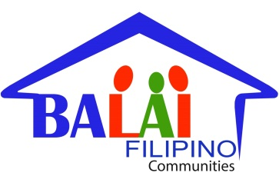
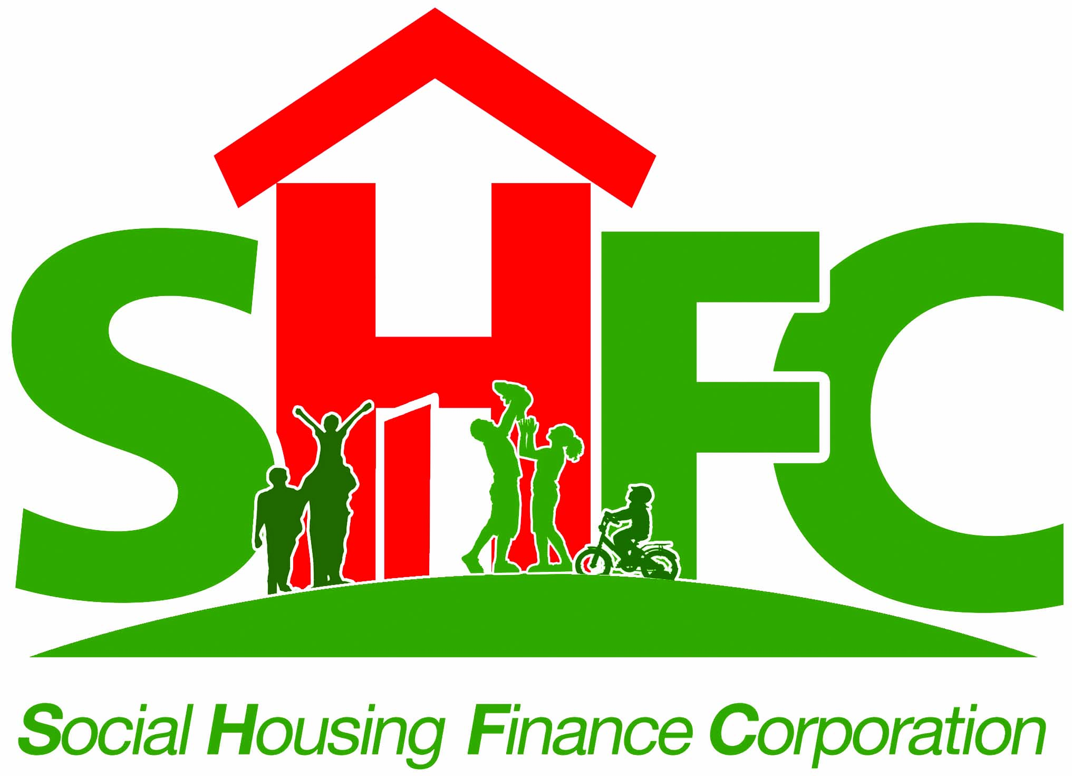
SOCIAL HOUSING FINANCE CORPORATION
PROGRAM DEVELOPMENT & ENHANCEMENT DEPARTMENT
PARTNER RELATIONS DIVISION

CHECKLIST OF REQUIREMENTS
FOR ACCREDITATION OF BUILDERS & DEVELOPERS

Name :
Office Address :

Contact Person and Designation :
Phone No. and E-mail Address :

No. | Documentary Requirement |  |  | Remarks
1. | Original Copy of Application Letter.
2. | - For Sole Proprietor: DTI Certified True Copy of Certificate Business Name of Registration and Government issued ID of the owner.
 | - For Corporation: SEC Certified True Copy of Certificate of Registration, Articles of Incorporation and By-Laws, Updated General Information Sheet, Secretary Certificate as to authorized representative and his/her Government issued ID.
3. | Updated Mayor’s Permit.
4. | DTI Certified True Copy of updated PCAB License.
5. | - Organizational Chart of the company showing the name of owners, key technical staff, personnel and their positions/designations, duly signed by authorized representative;  - List of contractor’s key technical personnel and their individual CV with picture (please see attached forms: PRD-CES-01a & PRD-CES-01b); and  - Government issued ID of authorized representative.
6. | Annual Audited Financial Statements for the last two (2) years, showing among others, the total and current assets and liabilities, with BIR stamped “received” or its duly accredited and authorized institutions:
 | 6.1 | Income Tax Return
 | 6.2 | Independent Auditor’s Report
 | 6.3 | Income Statement
 | 6.4 | Balance Sheet
7. | Business tax returns duly validated with the tax payments paid thru the BIR, authorized institutions or the Electronic Filing and Payment Systems (EFPS) for the recent quarter.
8. | Certified Copy of Tax clearance for the current year as issued by BIR to prove full and timely payment of taxes.
9. | BIR Certificate of Registration (TIN) with indication of VAT registered activity.
10. | List of completed projects (please see attached form: PRD-CES-02).
11. | Original or Certified copy of certificate of completed projects/ Certificate of acceptance.
12. | List of on-going projects (please see attached form: PRD-CES-03).
13. | List of contractor’s equipment units with proof of ownership (please see attached form: PRD-CES-04).
14. | Original favourable endorsement from CA and documents showing practice of Community driven & participatory approach for projects with SHFC if applicable. (Note: for CMP taken out and on-going projects)

Page 1 of 2

Page 2 of 2: CHECKLIST OF REQUIREMENTS
FOR ACCREDITATION OF BUILDERS & DEVELOPERS

Additional Requirements for Developers

15. | Certified True Copy of HLURB Certificate of Registration and License to Sell; and
16. | Original Copy of Membership certification of good standing with CREBA, OSHDP, or SHDA

*Please submit the above enumerated requirements in numerical order. Incomplete documents may result in the delay of your application. For any questions, contact Partner Relations Division at 750 6337 local 301.

Received by: ____________________________

Date : ____________________________

Page 2 of 2

